On female sexual abuse of children among religious sisters in New Zealand

There is a powerful misconception that the sexual predation of children and vulnerable adults within faith-based institutions is invariably an issue of male on male or male on female assault.
This is clearly not the case.
Indeed, within the Catholic Church in Aotearoa entities that had the highest total figures of likely peadophiles between the years 1950 to 1975, it was the 23 orders of nuns that are likely to have been the most dangerous of all. This was particularly true of the teaching orders who had access to children and who, after whānau, were the agents of enculturation of children into this faith.
Here is a list of twenty-three such congregations of religious sisters who have worked on New Zealand soil, compiled by the author in approximate chronological order. The number in brackets were the numbers still alive in 2010:
Twenty- Three Congregations of Religious Sisters
• Nga Whaea Atawhai o Aotearoa Sisters of Mercy New Zealand RSM 1850 Auckland (260)
• Congregation of Our Lady of the Missions RNDM 1867 Napier (112)
• New Zealand Dominican Sisters OP 1871 Dunedin (57)
• Sisters of St Joseph 1880 Whanganui (“Black Joes”) (36)
• Sisters of St Joseph of the Sacred Heart RSJ 1883 Temuka (“Brown Joes”) (75)
• Sisters of the Good Shepherd RGS 1886 Christchurch (10)
• Little Sisters of the Poor LSP 1888 Auckland (26)
• Daughters of our Lady of Compassion DOLC 1892 (First NZ Order) Wanganui River (69)
• Congregation of St Brigid (Brigidines) CSB 1898 Wellington (16)
• Sisters of Nazareth CSN 1905 Christchurch (4)
• Little Company of Mary LCM 1914 Christchurch (20)
• Marist Sisters SM 1927 Auckland (21)
• Missionary Sisters of the Society of Mary SMS 1931 (39)
• Discalced Carmelite Nuns OCD 1937 Auckland (13)
• Sisters of St Joseph of Cluny SJC 1940 Auckland (18)
• Sisters of the Presentation of the Blessed Virgin Mary PBVM 1951 Taita Wellington (12)
• Cenacle Sisters RC 1953 Auckland, Lower Hutt (6)
• Little Sisters of the Assumption LSA 1955 Dunedin (6)
• Sister Disciples of the Divine Master PDDM 1974 Auckland
• Sisters of the Holy Faith CHF (5)
• Missionary Sisters of St Peter Claver SSPC (3)
• Community of the Beatitudes - Our Lady of the Trinity 1994 Wellington
• Adorers of the Sacred Heart of Jesus of Montmartre OSB (“Tyburn Nuns”) (10) (www.catholic.org.nz/find-us/organisations/)

The Sisters of Mercy (RSM Ngā Whāea Atawhai), Our Lady of the Missions (RNDM), the Dominicans (OP) and the Sisters of St Joseph of the Sacred Heart (RSJ) made up the majority of the teaching sisters and all had arrived and were established by the end of the 19th Century. Abuse was not confined to these orders.
The great majority of abuse happened at the hands of these women, either as direct sexual abuse, extreme violence or as enablers of male predators, providing access to children and concealing the assaults, a criminal act in and of itself under the New Zealand 1961 Crimes Act, Section 71.
The predicted number of female sex offenders premised on the Australian Royal Commission figures that are themselves, a significant understatement of likely figures, have 103 offenders in 1950 and 112 in 1975.
Not a single one of these predicted offenders were ever charged with a crime while alive, let alone serve a day’s prison time.

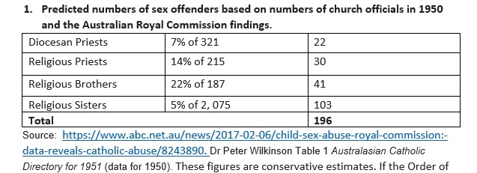

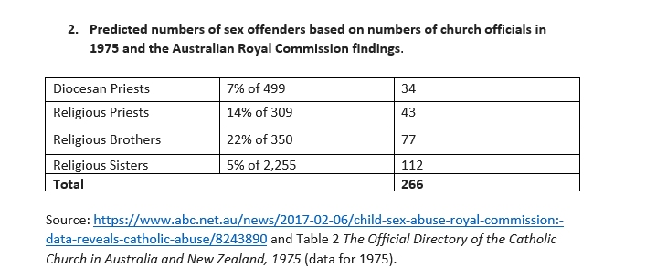
The most notable public outing of a sexually abusive nun was that reported by the victim “George” in an article written by Emily Spink on July the 1st, 2017. The prioress, Mother Lucia of the Sisters of Our Lady of the Missions sexually abused “George” in Christchurch in the 1960s, abuse which even the order acknowledged.
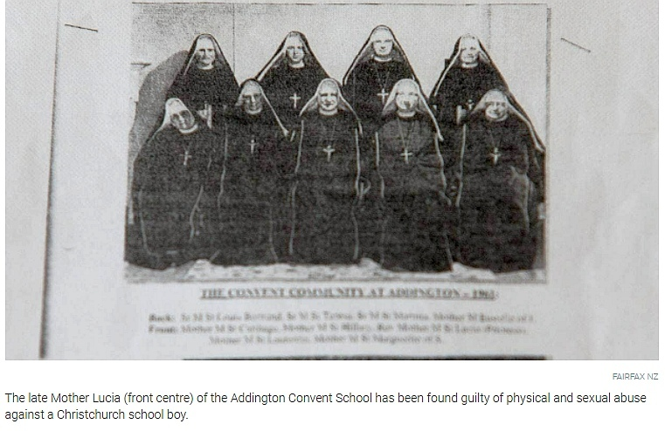
https://www.stuff.co.nz/national/94184801/man-robbed-of-his-innocence-by-nun-speaks-out-decades-later-about-his-quest-for-justice
Ann Thompson, in her autobiography, Say Sorry, spoke of her physical and sexual abuse in the Catholic Christchurch orphanage run by the Sisters of the Good Shepherd in the 1940s and 1950s
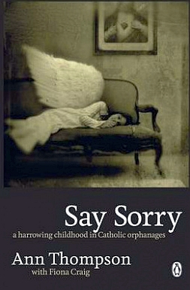
Father Tom Doyle, in the Epilogue he wrote for Ann’s book, Say Sorry, wrote “Why an adult would physically and sexually abuse a child has no rational answer. Those who do so are clearly disturbed. A far more pressing question, however, is why a trusted institution holding great stature in our society would not only permit the sexual abuse of the innocent, but would subsequently treat the victims with distain and even scorn…Without a shadow of a doubt, the most incomprehensible, shocking and page 357 destructive dimension of this epidemic of abuse is not the sexual and physical damage inflicted, but the response and attitude of the clergy and especially the bishops…From the Vatican down to the local dioceses and religious orders, the common response to the endless revelations of sexual abuse by clergy and members of religious orders such as brothers and nuns has, again, been minimisation, denial, blame shifting and lying…They are unwilling to confront the spiritual holocaust, in great part because they are incapable of comprehending the depth and extent of the spiritual damage” (p169, 174, 175)
https://www.fishpond.co.nz/Books/Say-Sorry-Ann-Thompson/9780143011842
On the 5th of December 2018, under the headline, Sisters of Mercy a dark misnomer, the journalist described abuse at two Sister of Mercy orphanages in Dunedin: St Joseph’s Boys Home and St Vincent de Paul Orphanage for Girls in nearby South Dunedin.
“Steve”, the male victim observed: "The nuns up there were supposed to be the Sisters of Mercy, but they were anything but ... They were supposed to be the brides of Christ, but they were more like the brides of Frankenstein."
The Australian commission also heard evidence of the emotional, physical and sexual abuse children suffered at the Australian orphanages, and that some children were punished by the nuns after confiding in a priest about being sexually abused while in care.

Some children had even been abused by priests who would visit Sisters of Mercy orphanages despite having no "formal responsibility" for the children there.
At St Joseph’s Boys Home in Dunedin, priests were also regular visitors.
One of them, Steve said, was Fr Magnus Murray.
In 2003, Murray was convicted of historical sexual offences against four Dunedin boys dating back to between 1958 and 1972.
He has since been implicated in further offending, including suggestions of at least 15 victims on the Taieri alone, but in the 1960s he was still a respected parish priest.”
https://www.odt.co.nz/news/dunedin/insight/sisters-mercy-dark-misnomer
Anne Hill, in her testimony to the Abuse in Care Royal Commission, spoke of the horrors of the Sisters of Mercy Star of the Sea orphanage in Howick, Auckland and the failure of the nuns to protect her from her assailant, the Dominican priest, Father Michael Shirres or from “the physical, emotional and sexual abuse” suffered at various home placements. The Sisters of Mercy acted as conduits and enablers of sexual abuse.
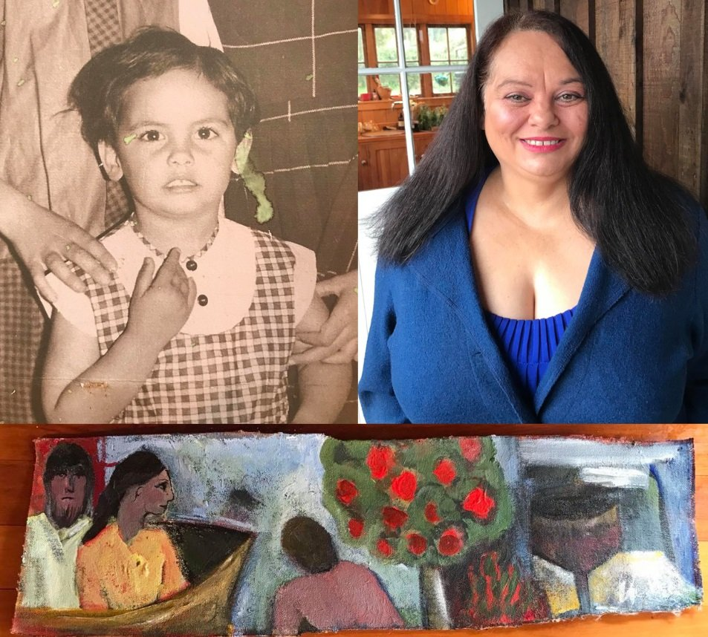
https://www.facebook.com/Star-of-the-Sea-Orphanage-Howick-SurvivorsOrphansBoarders-511515109043899/
Mike Ledingham, like his brothers, was sexually abused by Father Frank Green while at St Joseph’s, a school run by the Sisters of Mercy in Onehunga, Auckland, The head nun, Sister Antony, was responsible for sending the children up to the presbytery whenever the priest commanded her too and was thus fully complicit in the harm inflicted on them. We are reliable informed she was fully aware of complaints against him and decided to not only ignore them but accuse the children of lying.
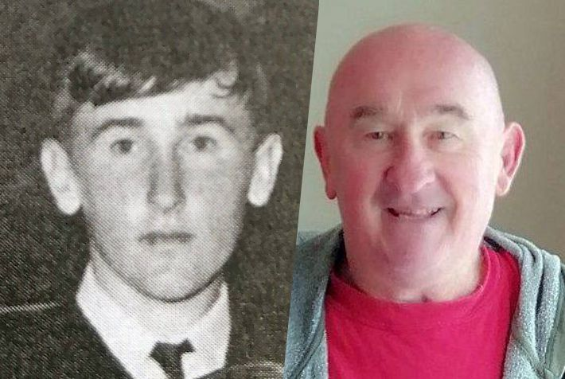

More extreme violence at the hands of Sisters of Mercy was reported by Morris with the testimony of Russell Butler, a man dying of cancer, severely assaulted by a Sister James, the head nun at St Mary’s, Mosgiel (near Dunedin).
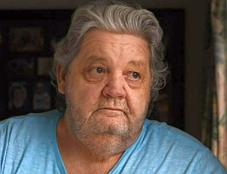
https://mail.malesurvivor.nz/brutal-lesson-story-of-abuse-by-dunedin-nun/

Alexandra Murray was orally raped as a child by Father Peter McCormack (later jailed for sexual assault of a minor) in a room of the St Joseph’s Orphanage, Upper Hutt, while Sisters of Mercy were outside the door.
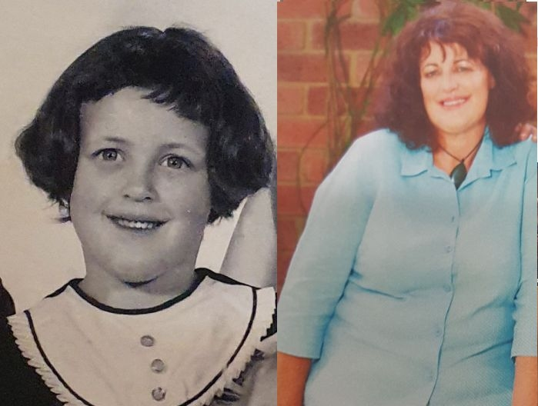
On the 8th of November, 2019, Annasophia Calman, a witness at the Abuse in Care Royal Commission reported being raped by a nun of the Sisters of Nazareth at St Joseph’s Orphanage in Christchurch.
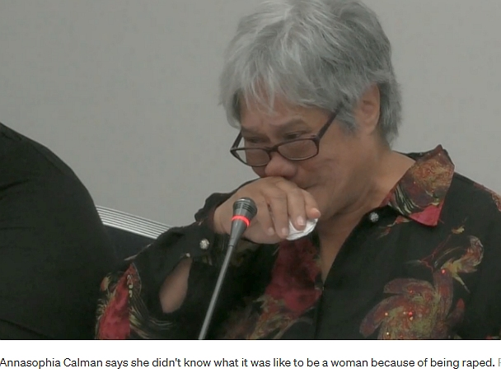
https://www.rnz.co.nz/news/national/402840/abuse-survivor-raped-at-foster-homes-sexually-abused-by-nun

Gloria Ramsay, who gave witness at the Abuse in Care Royal Commission. was sexually assaulted by Doctor Father Francis “Frank” Terry at St Mary’s Northcote, an assault that was concealed and thereby enabled by the Dominican Sisters who ran the school prior to 1967. The nuns described Terry “as the closest thing to God”
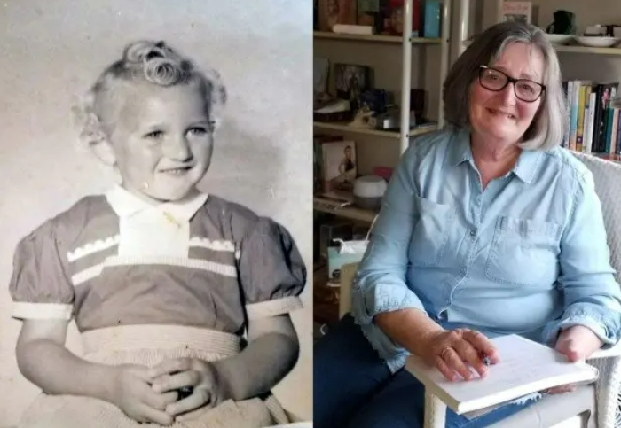
https://www.thereckoning.nz/episode-11-glo-ramsey/

Nor were the Sisters of Mercy, The Sisters of the Good Shepherd, the Sisters of Our Lady of the Missions, the Sisters of Nazareth and the Dominicans alone in being active in or complicit in serious assaults against children
Violence was inflicted on Patrick Healey by the Sisters of St Joseph of the Sacred Heart (RSJ), reported on June the 1st, 2019 at Port Chalmers, one of the first schools opened by this Mary McKillop order of nuns, also known as the Brown Joeys.
https://mail.malesurvivor.nz/brutal-lesson-story-of-abuse-by-dunedin-nun/
The role of nuns as co-conspirators and concealers of sexual assault, again came to light recently when we were made aware of the autobiography of the Sisters of St Joseph nun, Sister Louise O’Kane who had served in the Māori community of Panguru, Hokianga. While writing it, she observed to listeners “the fathers would often ring and ask for a specified boy in their care to be sent over to them…the boys never wanted to go and would come back crying, but they enjoyed it.”
The fathers she is referring to were Mill Hill Missionary priests, fluent Te Reo speakers with full access to vulnerable Māori tamariki. This nun is describing a criminal activity as if it were of no account. All priests and all Brown Joey nuns who served in this heartland of Māori Catholic life from 1918 onwards (when the nuns started there), need to be listed and their actions forensically examined.

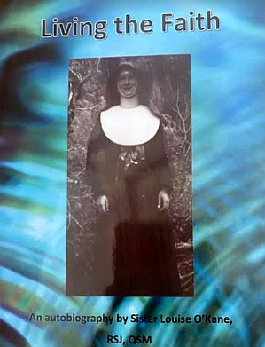

This fundamental role of females in the sex abuse of children and vulnerable adults is a global pattern evidenced throughout the world in Canada, the United States, South America, Europe, Asia, Africa, Australia and New Zealand.
Despite its ubiquity, governments have been remiss in accepting the reality of this abuse by female perpetrators, refusing to acknowledge the clear evidence placed before them
https://www.globalsistersreport.org/news/news/news/survivors-sex-abuse-nuns-suffer-decades-delayed-healing
The Network of Survivors of Abuse and Their Supporters was in Rome in February, 2020 to support Ezequiel Villalonga, Daniel Sgardelis and Claudia Laubeguerie, deaf survivors from the Mendoza (Western Argentina) Provolo Institute.
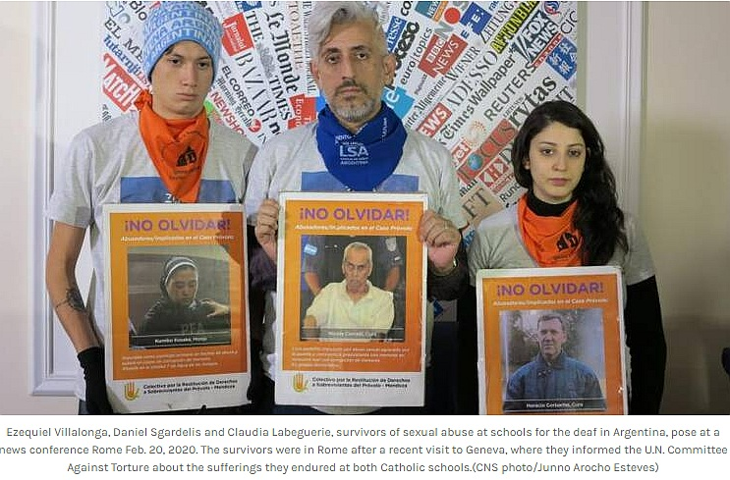

Sister Kosaka Kumiko (the poster in Mr Villalonga’s hands) not only enabled Fathers Corbaco and Corradi (also pictured) but took part in the assaults herself,
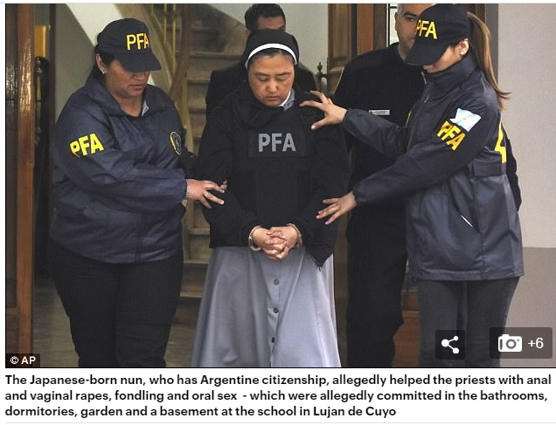

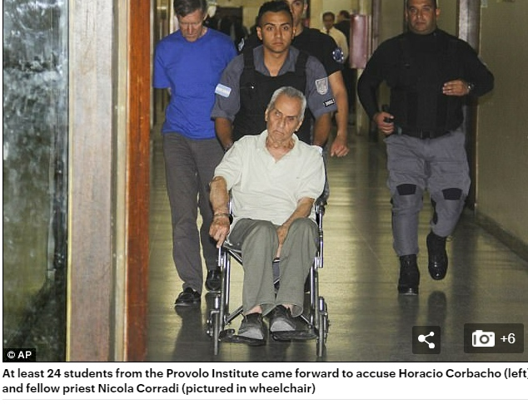

The case of “George” outing his abuser, Mother Lucia, is rare for the simple reason most men believe they won’t be believed it was a female who committed the offence or who enabled the offence.
“Human Rights lawyer Sonja Cooper said it was the first case she was aware of, where sexual abuse by a nun had been accepted by the church through the Path to Healing Protocol.
"There is this general societal view that women don't abuse."
"We've had a significant number of our male clients, who were in care and social welfare that have been sexually abused by female caregivers. It is very very difficult to get the Ministry of Social Development to accept that women are abusers.
"There is just this attitude that women don't abuse and 'oh yes, they do'." That can be extremely damaging and destructive and can distort the perceptions of the victims."
https://www.stuff.co.nz/national/94184801/man-robbed-of-his-innocence-by-nun-speaks-out-decades-later-about-his-quest-for-justice

Sonja Cooper is correct. Based on the Australian findings, female sexual abuse of children is predicted to have been greater than that perpetrated by diocesan priests, religious priests and religious brothers combined in 1950 and greater than diocesan and religious brothers combined in 1975 through sheer weight of numbers and opportunities to offend in church institutions including- and in particular-numerous day schools but also boarding schools and orphanages.
This is a reality we as a nation are obliged to confront because the consequences have been devastating and still largely ignored.

